**ASSIGNMENT 1**

**SMART HOME AUTOMATION USING TINKERCAD**

|  |  |
| --- | --- |
| Assignment Date | 16 September 2022 |
| Student Name | Ms. Angelyn Sweety I |
| Student Roll Number | 312319106011 |
| Maximum Marks | 2 Marks |

**QUESTION:**

**Make a Smart Home in Tinkercad, using 2+ sensors, Led, Buzzer in single code and circuit.**

**Solution:**

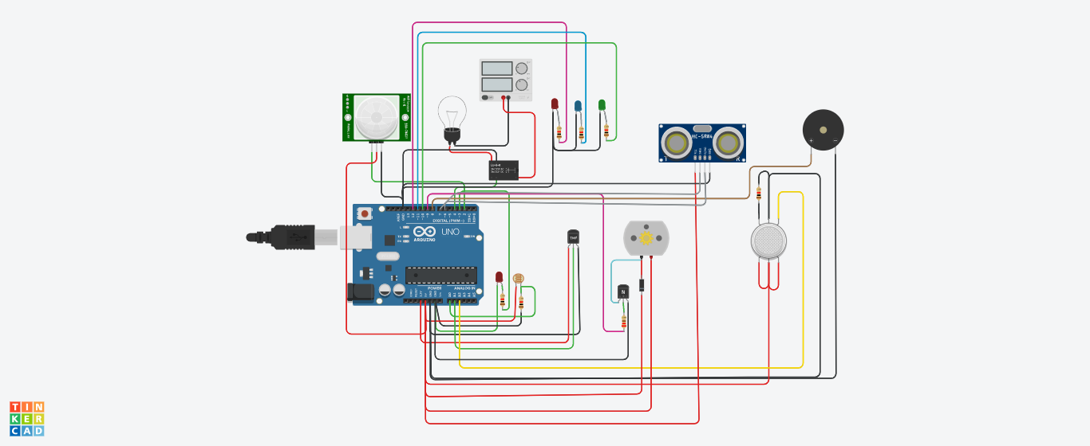

**Required Components:**

* Arduino Uno R3
* Photoresistor
* 1 kΩ Resistor
* Red LED
* PIR Sensor
* Relay SPDT
* Power Supply
* Light bulb
* Temperature Sensor [TMP36]
* Piezo(buzzer)
* Gas Sensor
* DC Motor
* NPN Transistor (BJT)
* 220 Ω Resistor
* Diode
* Ultrasonic Distance Sensor
* Green LED
* Blue LED

**Working Model:**

The Brightness of the LED is adjusted according to the Ambient Light intensity of the room. This is achieved using LDR sensor whose resistance is dependent on light intensity.

Motion of Human is detected using PIR Motion Sensor and if a Human Presence is detected, Bulb in the room is turned ON; else the Bulb is turned OFF.

The Ambient temperature of the room is detected using TMP36 and accordingly, the speed of the fan is controlled. The RPM of the motor is proportional to the temperature. Here the fan is considered as a DC motor.

The gas Sensor is used to sense the gas and give an alert signal via buzzer.

The Ultra Sonic Sensor is used to monitor the level of the water in the tank. When the level of the water is between 0 and 150, the Green LED is turned ON. If the level of the water is between 150 and 250, the Blue LED is turned ON. When the water level is above 250, the Red LED is turned ON.

**Code:**

// SMART HOME AUTOMATION

#define t 7

#define e 6

#define led1 10

#define led2 11

#define led3 12

#define motor 9

#define led 3

#define pir 2

#define bulb 4

#define gas_sensor A2

void setup()

{

Serial.begin(9600);

pinMode(motor, OUTPUT);

pinMode(led, OUTPUT);

pinMode(pir, INPUT);

pinMode(bulb, OUTPUT);

pinMode(t, OUTPUT);

pinMode(e, INPUT);

pinMode(led1,OUTPUT);

pinMode(led2,OUTPUT);

pinMode(led3,OUTPUT);

}

void loop()

{

//LED BRIGHTNESS CONTROL BASED ON AMBIENT LIGHT

int light_intense=analogRead(A0);

int res=map(light_intense,0,679,255,0);

Serial.print("Light Intensity in the room:");

Serial.println(res);

analogWrite(led,res);

//Motion Detection -- bulb on or off

int pir_op=digitalRead(pir);

if(pir_op==1)

{

digitalWrite(bulb,pir_op);

Serial.println("Motion detected : bulb ON");

}

else

{

digitalWrite(bulb,pir_op);

Serial.println("Motion Not detected : bulb OFF");

}

//Temperature sensor and Fan as the dc motor

int celsius;

celsius = map(((analogRead(A1) - 20) * 3.04), 0, 1023, -40, 125);

Serial.print("Temp in Celsius:");

Serial.println(celsius);

int speed = map(analogRead(A1),0,1023,0,255);

analogWrite(motor,speed);

//gas sensor with buzzer alert

int val = analogRead(gas_sensor);

Serial.print("Gas Sensor Value = ");

Serial.print(val);

if (val > 100)

{

Serial.println("\tSmoke is Detected");

tone(8, 220, 100);

delay(50);

}

delay(10);

Serial.println("\tSmoke is not Detected");

noTone(8);

//Tank Water level Monitoring

digitalWrite(t, LOW);

digitalWrite(t, HIGH);

delayMicroseconds(10);

digitalWrite(t, LOW);

float dur= pulseIn(e,HIGH);

float dist=(dur/2)*0.0343;

Serial.print("Distance in cm: ");

Serial.print(dist);

if(dist> 0 && dist<=150)

{

digitalWrite(led1, HIGH);

digitalWrite(led2, LOW);

digitalWrite(led3, LOW);

Serial.println("\tWater Level is Low");

}

else if(dist>150 && dist<=250)

{

digitalWrite(led2, HIGH);

digitalWrite(led1, LOW);

digitalWrite(led3, LOW);

Serial.println("\tWater Level is Moderate");

}

else if(dist>250)

{

digitalWrite(led3, HIGH);

digitalWrite(led1, LOW);

digitalWrite(led2, LOW);

Serial.println("\tWater Level is High. Switch Off the motor");

}

delay(1000);

}

**Simulated Output;**

**Sample:**

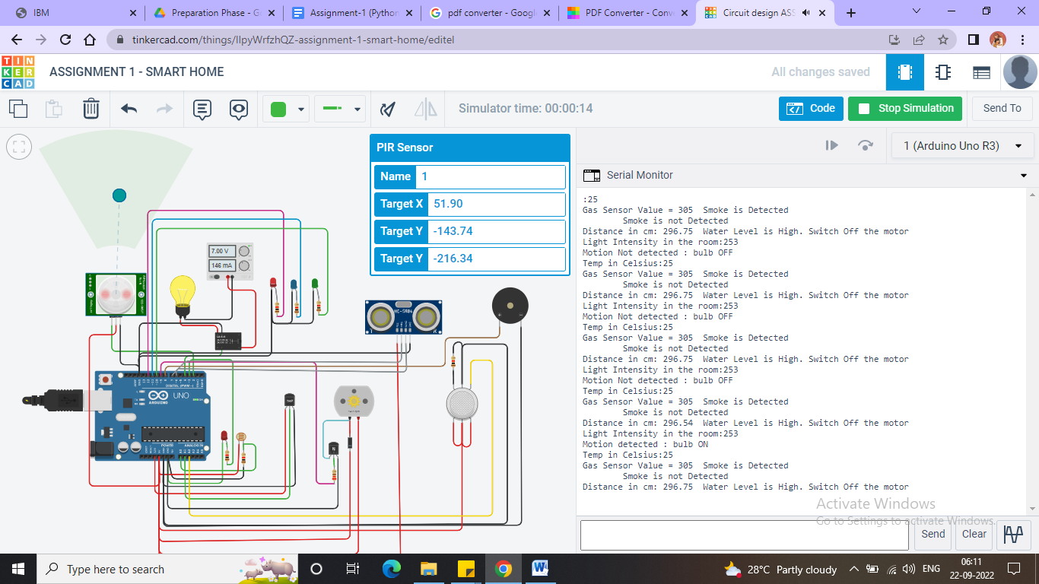

Light Intensity in the room:253

Motion detected : bulb ON

Temp in Celsius:25

Gas Sensor Value = 85 Smoke is not Detected

Distance in cm: 296.75 Water Level is High. Switch Off the motor

**Simulation Link**:

https://www.tinkercad.com/things/lIpyWrfzhQZ-assignment-1-smart-home/editel